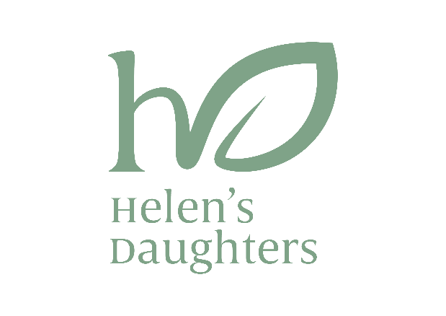
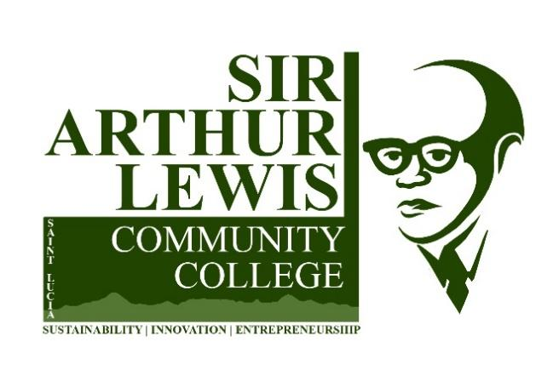
APPLICATION FORM FOR THE HELEN’S DAUGHTERS ANNUAL SCHOLARSHIP

This application form must be completed accurately, and in full, by the applicant.
To make the most suitable arrangements, detailed responses are requested.

Which Programme have you been offered a place for?

- General Agriculture
- Climate Smart Agriculture (Crop Production)

Did you receive a conditional offer for this programme? □ Yes □ No
If yes, specify the additional (Foundation) course(s) that you need to do in part 4 on page 2.
- Personal Information:
a. Name | Surname (Last Name):  Given Name(s) :
b. Nationality
^{c. Parents} | Father | Mother
 | Name:  Occupation:  Contact Information:  Address: | Name:  Occupation:  Contact Information:  Address:
d. Applicant Contact Information | Telephone:  Email Address:  Address:
e. Marital status | □ Single □ Married □ Divorced/Separated □ Common-Law
f. Date of birth | Day _______________／Month _________／Year ____________

- Education and Training
School name | Subject | Qualification  (Certificate/Diploma/  Degree) | Grade/G.P.A  obtained | Year obtained
- Employment/Job Experience (If applicable)
Position | Company/Organization | Period of employment | Responsibilities

- What prerequisite courses will you need to do when you start your preferred programme?
Course(s):

- DECLARATION: I hereby declare that:

- The information I have provided in this document is true and accurate.

- I understand that any false information will disqualify me from the programme, even if it is already in progress.

- I am presently enrolled as a student in the Agri-Entrepreneurship and Climate Smart Agriculture Programme at the Sir Arthur Lewis Community College.

- I consent to the Sir Arthur Lewis Community College providing my grades to the Helen's Daughters Organization at the conclusion of each academic semester.

Applicant’s signature Date

______________ ／_____________ ／___________
Day Month Year

