VACANT POST NOTICE
FACULTY- SOCIOLOGY

ABOUT THE SIR ARTHUR LEWIS COMMUNITY COLLEGE

Sir Arthur Lewis Community College, the premier tertiary learning institution in Saint Lucia, was established in 1985 and named after the world-famous economist and Nobel Laureate, Sir William Arthur Lewis. The College, which is currently in transition to University status, offers a wide range of cutting-edge and globally relevant academic and technical programmes from Bachelor’s and Associate degrees to TVET and Executive and Leadership training. Our programmes are undergirded by three main pillars: Sustainability, Innovation and Entrepreneurship. These goals are in keeping with the Government of Saint Lucia’s commitment to the implementation of the United Nations (UN) Sustainable Development Goals.

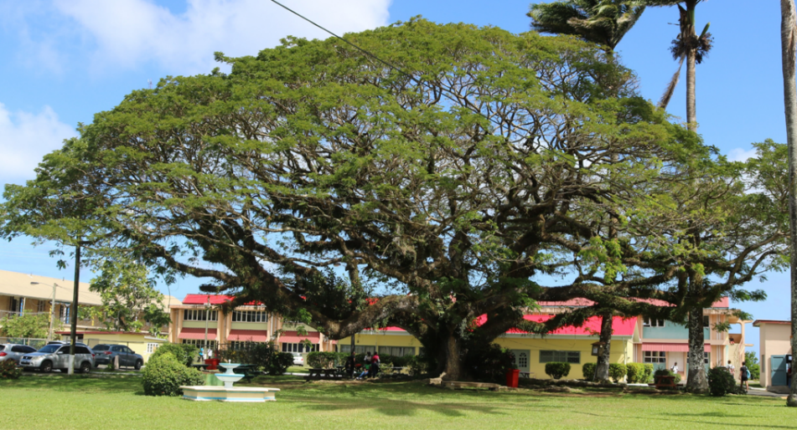

The College has two campuses (Main Campus at Morne Fortune, Castries and South Campus in Vieux Fort) and an Experimental Farm in Dennery. The College is governed by a Board of Governors and a Management Team led by the Principal/President and Vice Principals. The Management Team includes Deans and Programme Heads that manage the day-to-day operations of the institution, including its 130 faculty members and 165 supporting staff members.

Applications are invited from suitably qualified persons to fill the following Faculty positions at the Sir Arthur Lewis Community College (SALCC) in the following subject area:

- Sociology

JOB SUMMARY

Faculty is responsible for the coordination, planning, preparation, presentation and evaluation of classroom instruction and related activities. The related activities include instruction, instructional counseling, academic advising, serving on various committees, participating in local, state, regional, and national professional activities and organizations.

Under the supervision of the Dean/ Programme Head, faculty have as their chief duty the instruction of assigned classes. This duty takes precedence over all others. In addition to their teaching responsibilities, faculty should assume responsibility for professional development, service to the college, and other duties as assigned by their Dean/ Programme Head. A typical faculty work schedule varies from semester to semester (scheduled responsibilities) and week to week (non-scheduled responsibilities) to best accommodate student learning, professional development, and service to the College.

QUALIFICATIONS AND EXPERIENCE

At least Masters’ Degree in the subject area.

A Certificate in Teaching is preferred; the selected candidate who does not hold a teaching certificate will be required to obtain one

SKILLS AND OTHER ATTRIBUTES REQUIRED
- A demonstrated ability to successfully connect to young persons of diverse skills, interests and perspectives.
- Ability to identify learning styles, talent and skills
- Evidence of excellent oral and written communication skills
- Evidence of excellent analytical and problem solving skills.
- Exhibit emotional control and stability
- Mastery of appropriate computer operation skills

CORE FUNCTIONS AND MAIN RESPONSIBILITIES
Instruction
- Facilitate student learning, provide effective instruction, and perform evaluations of student learning for all assigned classes, using each course's standard course outline as a guide;
- Develop course curriculum, course handouts, lectures, labs, and presentations where appropriate;
- Participate in summative and formative faculty evaluation process;
- Participate in program level learning assessment. Participation includes helping articulate learning outcomes, choosing and administering measures, evaluating student performance, and suggesting changes to improve student learning;
- Work with other faculty and administrators in developing and reviewing program curriculum, standards, policies and processes including reviewing and participating in textbook selection process where appropriate;
- Schedule, supervise, debrief, and evaluate students in clinical, internship, observation, field experience, and similar settings as appropriate for the course or program;
- Assign grades and maintain course/student records in accordance with SALCC regulations and submit grades and records by established deadlines;
- Meet all classes and other scheduled responsibilities such as office hours and meetings at the designated times.

RESEARCH AND PROFESSIONAL DEVELOPMENT
- Conduct research / engage in in research activities related to the subject area/discipline;
- Remain current in academic or program discipline, including maintaining licensure, certification, or continuing education requirements where appropriate;
- Receive training or stay current in technological or pedagogical advances that promote student learning;
- Participate in College professional development activities;
- Read journals in the teaching field

Service to the Division and the College

- Serve on/ work with technical teams on initiatives aimed at the development of the College;
- Attend local, regional, state, or national meetings where required or necessary for the discipline;
- Mentor and assist in orienting new faculty, either formally or informally where appropriate or required by department or division;
- Participate in graduation ceremonies or other ceremonies appropriate to the faculty member's discipline or program;
- Participate in departmental, divisional, and college-wide meetings where appropriate or as required by supervisor;
- Perform other academically-related duties as assigned by the Dean;
- Promote the College in the Community by participating in a variety of marketing activities;
- Initiate/Participate in service activities/projects involving the College and its external communities

APPLICATION PROCEDURE

Interested, eligible candidates are invited to apply by completing the prescribed forms. Applications should include brief curriculum vitae, verified copies of relevant certificates and qualifications and at least two letters of reference confirming the required experience, skills and disposition of the applicant. Completed Applications must be submitted as one PDF document to salccrecruitment@apps.salcc.edu.lc

Deadline for receipt of all applications is
January 13, 2023.

TERMS OF APPOINTMENT

Appointment will be a one (1) year contract with the possibility of renewal based on the College’s need and performance.

The salary will be determined by the qualifications of the applicant and in accordance with the salary scales approved by the College.

Quarters, transportation to and from work, free medical attention and medicines will not be provided. The successful applicant’s income will be liable to taxation in accordance with the local Income Tax Ordinance.

INCOMPLETE APPLICATIONS WILL NOT BE ACKNOWLEDGED.

The Manager
Sir Arthur Lewis Community College
Morne Fortune
CASTRIES
Tel.: 758-457-7312

salcc.edu.lc
SALCC
sir_arthur_lewis
SirArthurLewis
SALCC

